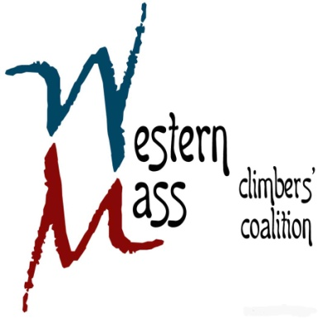

**2nd Quarterly Meeting Agenda**

**Friday May 15th, 2015 / 6:30 PM / CRG Hadley**

**Financials** (*15 mins*)

* Current standing
* Membership update

**Upcoming Events** *(30 mins)*

* Rendezvous planning
* Adopt-a-Crag
* Summer BBQ / Other

**Access Projects** *(40 mins)*

* Becket Quarry
* High Rocks
* Frost Giants, Happy Valley, and Hideaway
* DCR update

**Open Forum** *(5 mins)*

* Any remaining items